EJADA EGYPT SUMMER INTERNSHIP PROGRAM 2026
CLOUD BUILD TRACK
OCI Cloud Infrastructure Lab
Week 2 — Lab 2
Compartment | intern-20-mohamed-essam-cmp
Region | Saudi Arabia West (Jeddah) — me-jeddah-1
Build Window | Aug 12, 2026, 19:39 UTC – Aug 13, 2026, 01:23 UTC
Prepared By | Mohamed Essam
Document Type | Submission-Ready Technical Deployment Report

1. Lab Overview & Objectives
This report documents Week 2 (“Lab 2”) of the Ejada Egypt Summer Internship Program 2026 – Cloud Build Track. The lab's goal was to design and provision a segmented two-tier network on Oracle Cloud Infrastructure (OCI), deploy a private application instance, attach durable shared storage over NFS, and expose the application to the internet through a public Application Load Balancer — while keeping the compute tier and storage tier fully isolated from direct internet access.
All work was carried out in compartment intern-20-mohamed-essam-cmp, region Saudi Arabia West (Jeddah) (me-jeddah-1), as shown consistently across every console screenshot in this batch.

Objectives
- Provision a custom VCN with segregated public and private regional subnets.
- Configure Internet, NAT, and Service Gateways, and bind each subnet to a purpose-built route table for controlled ingress/egress.
- Apply least-privilege Security List rules that open only the ports each tier actually needs (HTTP/HTTPS on the public tier; LB→app, SSH, and NFS ports on the private tier).
- Deploy an OCI Bastion service to provide administrative SSH access into the private subnet without a public IP or an always-on jump host.
- Launch a private compute instance running the application on port 80.
- Provision an OCI File Storage file system and mount it to the compute instance over NFS for persistent application data.
- Deploy a public Application Load Balancer with a healthy backend set in front of the private instance.
- Where evidenced, codify the above using Terraform Infrastructure-as-Code (see Section 10).

2. Architecture Diagram
The diagram below summarizes the logical flow of traffic confirmed by the screenshots: inbound requests reach the public Load Balancer over the internet, the Load Balancer forwards to the application on the private compute instance, and the instance persists data to OCI File Storage over NFS.
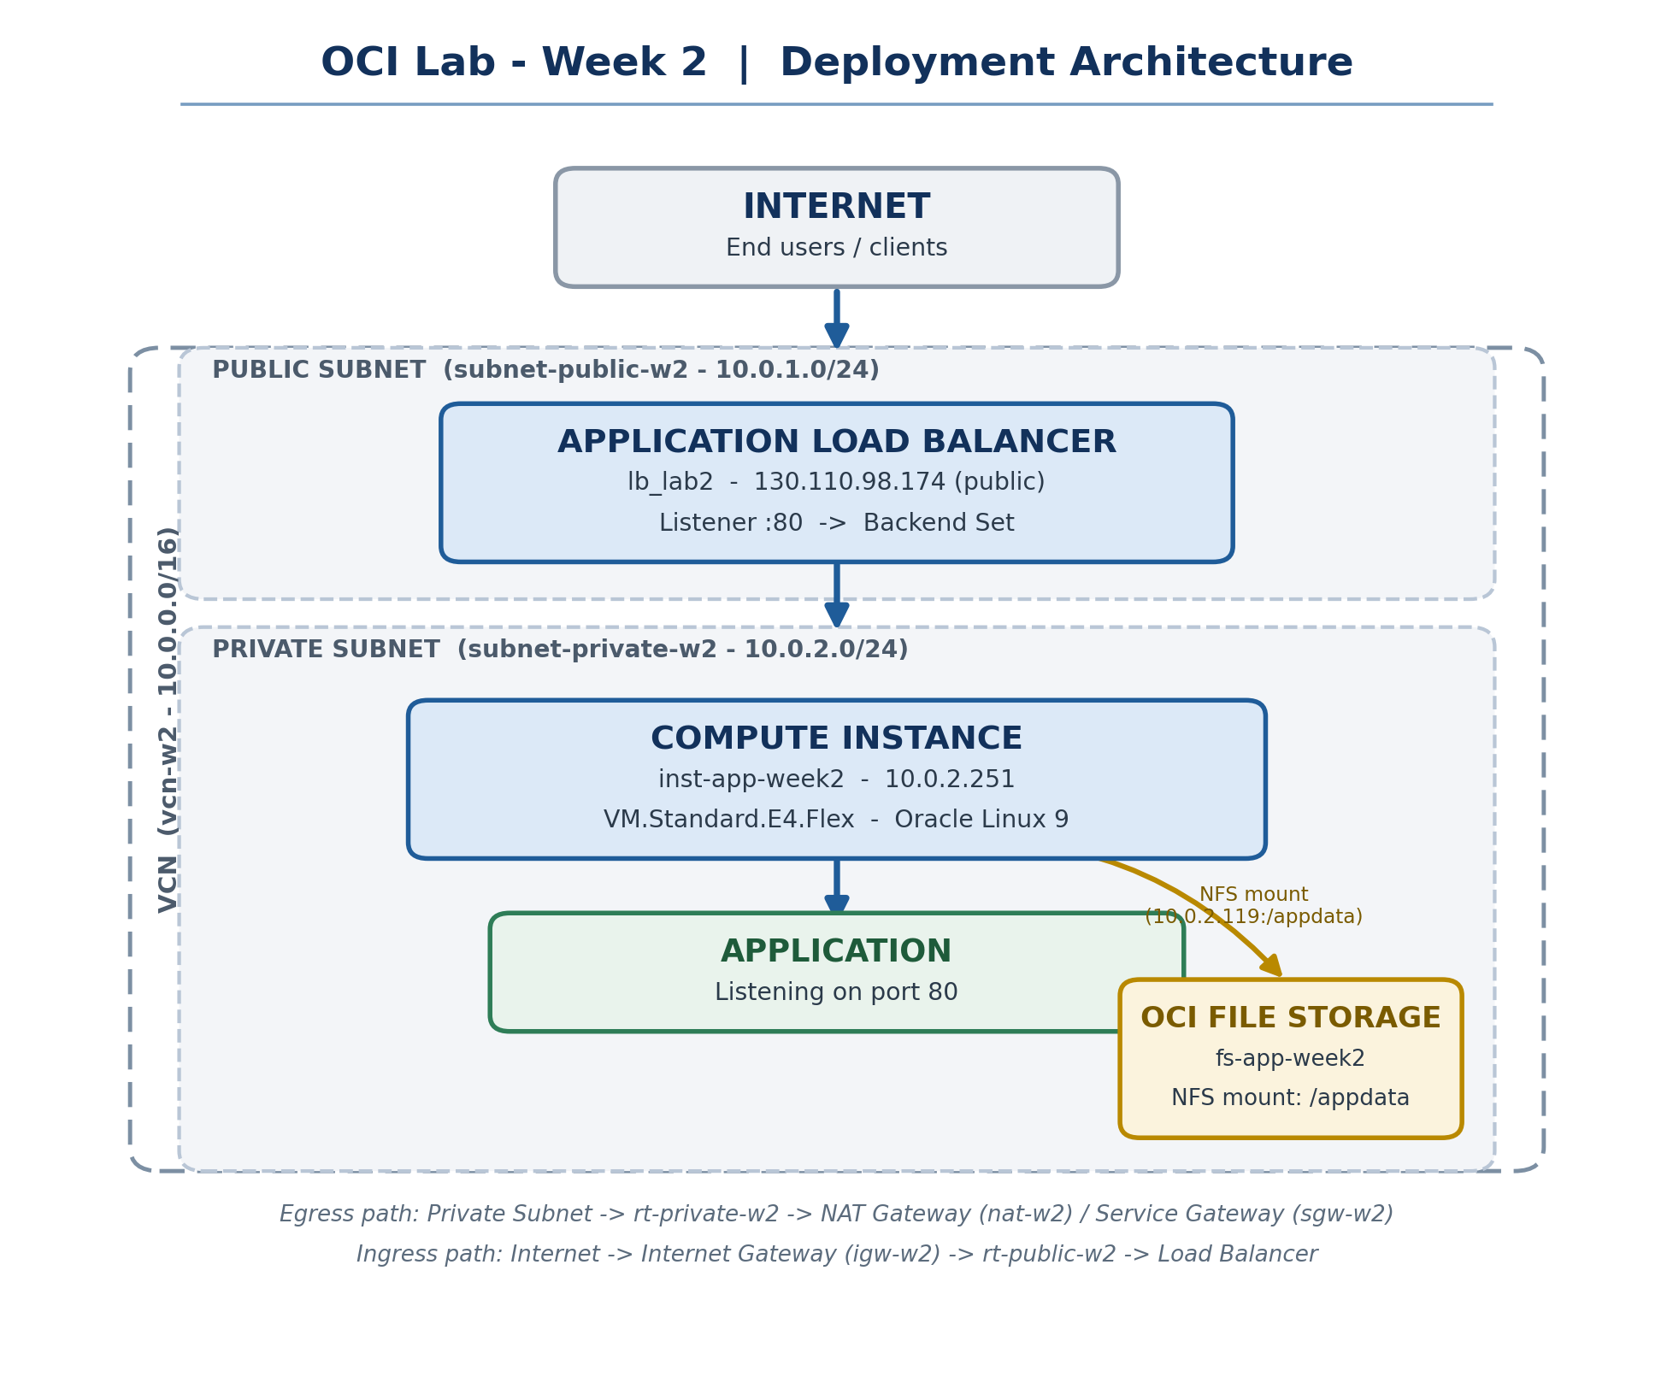
Diagram 1 — Logical deployment architecture, built strictly from confirmed lab resources.

Traffic Flow
Ingress: Internet → Internet Gateway (igw-w2) → rt-public-w2 → Load Balancer (lb_lab2, 130.110.98.174) → Backend Set → Compute Instance (inst-app-week2, 10.0.2.251) on port 80.
Egress: Compute Instance → rt-private-w2 → NAT Gateway (nat-w2) for general internet-bound traffic, or → Service Gateway (sgw-w2) for Oracle-native service traffic.
Storage: Compute Instance → NFS mount (10.0.2.119:/appdata) → OCI File Storage (fs-app-week2), entirely within the private subnet's address space.

3. Prerequisites
The following access and configuration items are evidenced by, or directly implied by, the resources shown in the screenshots:
Prerequisite | Detail
OCI Tenancy / Region | Access to the Saudi Arabia West (Jeddah) region (me-jeddah-1).
Compartment | intern-20-mohamed-essam-cmp, with permissions to manage Networking, Compute, File Storage, Load Balancer, and Bastion resources.
IAM Permissions | Sufficient policy grants to create VCNs, subnets, gateways, route tables, security lists, bastions, compute instances, file systems, and load balancers in the compartment above.
Administrator Public IP | A known egress IP for CIDR allow-listing on the Bastion service (41.46.149.202/32 observed in Figure 14).
Platform Image | Oracle Linux 9 platform image availability (Oracle-Linux-9.8-2026.07.20-1, confirmed on the instance).
SSH Key Pair | Implied by the OCI Bastion session model used for private-subnet access; key material itself is not visible in any screenshot and is correctly not captured here.

PART A
Manual OCI Console Implementation
All resources below were provisioned by hand through the OCI Console, as evidenced by the console UI captured in each figure.

4. Manual OCI Console Implementation
This phase established the complete networking, compute, storage, and load-balancing stack using the OCI Console's point-and-click workflows, prior to any Infrastructure-as-Code work. The build proceeded in the order: VCN → subnets → gateways → route tables → security lists → bastion → compute instance → file storage → mount → load balancer, which is also the order this report follows in Sections 5–8.
Context | Value
Compartment | intern-20-mohamed-essam-cmp
Region | Saudi Arabia West (Jeddah) — me-jeddah-1
Build window (per resource timestamps) | Aug 12, 2026, 19:39 UTC → Aug 13, 2026, 01:23 UTC
Interface used | OCI Console (web UI)

5. Networking Configuration
The network foundation consists of one custom VCN, two regional subnets, three gateways, three route tables, three security lists, and one Bastion service. Each is documented below in the order it was built.

5.1 Virtual Cloud Network
Figure 1 — Virtual Cloud Network Details — vcn-w2
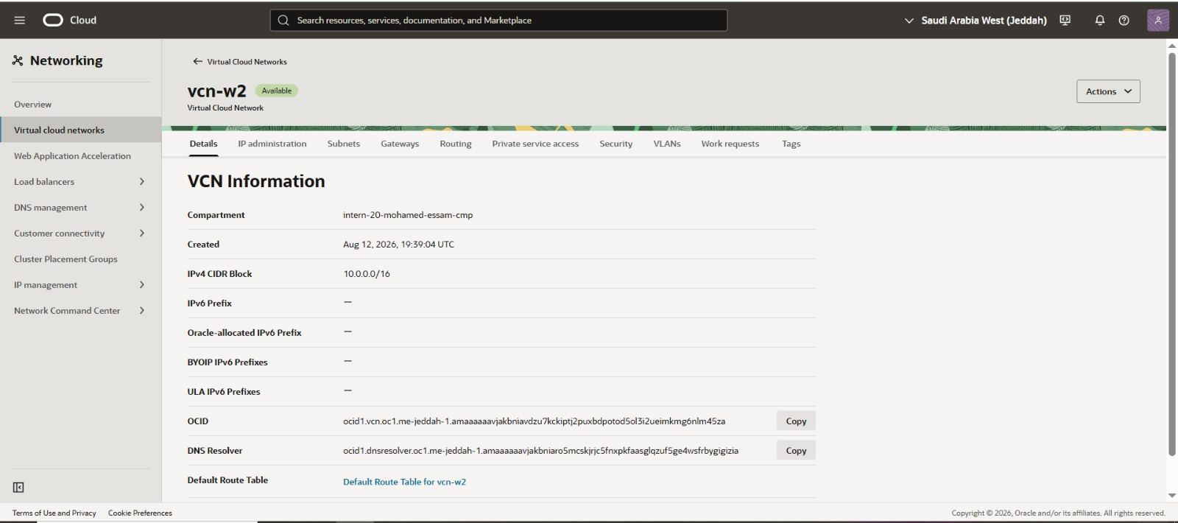

WHAT: A custom Virtual Cloud Network named vcn-w2 was provisioned with IPv4 CIDR block 10.0.0.0/16 inside compartment intern-20-mohamed-essam-cmp, region Saudi Arabia West (Jeddah).
WHY: The VCN is the isolated address space and routing domain that hosts every subnet, gateway and route table used in the lab.
PROVES: Confirms the VCN OCID, creation timestamp (Aug 12, 2026, 19:39:04 UTC), CIDR block, and the associated Default Route Table.

5.2 Subnets
The VCN was split into a public subnet (fronting the Load Balancer) and a private subnet (hosting compute and storage).
Figure 2 — Subnets Overview — vcn-w2
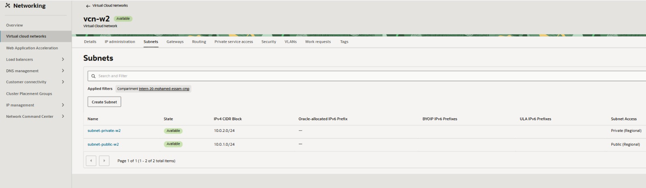

WHAT: Two regional subnets were created inside vcn-w2: subnet-public-w2 (10.0.1.0/24, Public) and subnet-private-w2 (10.0.2.0/24, Private).
WHY: Splitting the VCN into a public and a private subnet enforces tier separation — the load balancer sits in the public subnet while the application instance and file storage stay unreachable from the internet.
PROVES: Confirms both subnets are in the Available state with the exact CIDR ranges and subnet-access mode (Public/Private) used throughout the rest of the build.

Figure 3 — Public Subnet Details — subnet-public-w2
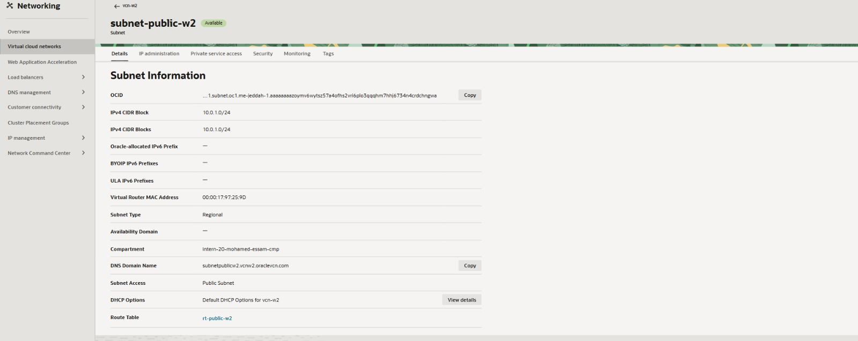

WHAT: Detail view of subnet-public-w2, CIDR 10.0.1.0/24, DNS domain name subnetpublicw2.vcnw2.oraclevcn.com, associated with route table rt-public-w2.
WHY: Verifies the exact routing and DNS configuration the public subnet (and therefore the Load Balancer) depends on.
PROVES: Confirms Subnet Access = Public Subnet and the Route Table binding to rt-public-w2.

Figure 4 — Private Subnet Details — subnet-private-w2
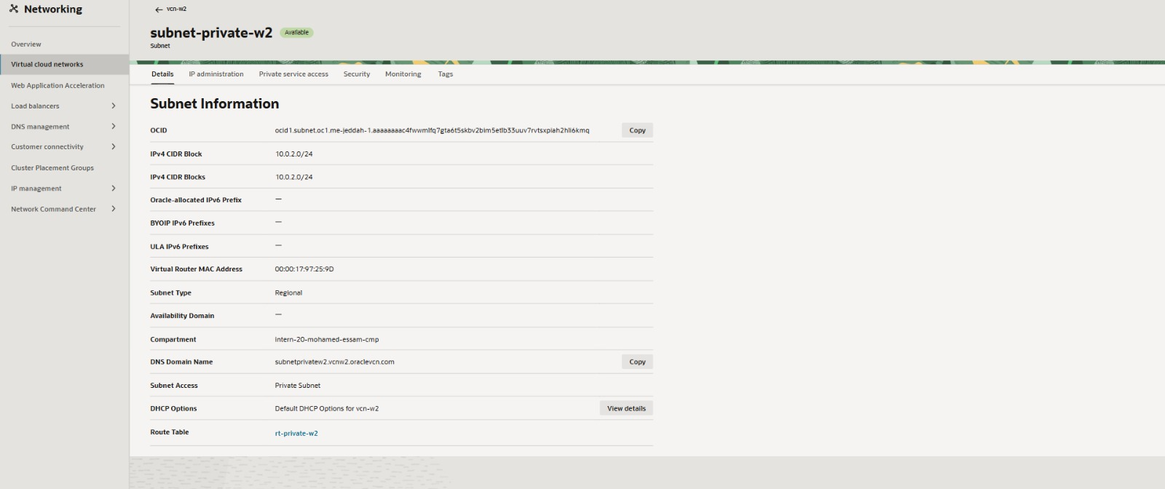

WHAT: Detail view of subnet-private-w2, CIDR 10.0.2.0/24, DNS domain name subnetprivatew2.vcnw2.oraclevcn.com, associated with route table rt-private-w2.
WHY: This is the subnet that will host the compute instance, the bastion target, and the file-storage mount target — all without direct internet exposure.
PROVES: Confirms Subnet Access = Private Subnet and the Route Table binding to rt-private-w2.

5.3 Gateways
Three gateways provide the VCN's connectivity to the outside world and to Oracle-native services:
Figure 5 — Internet Gateway — igw-w2
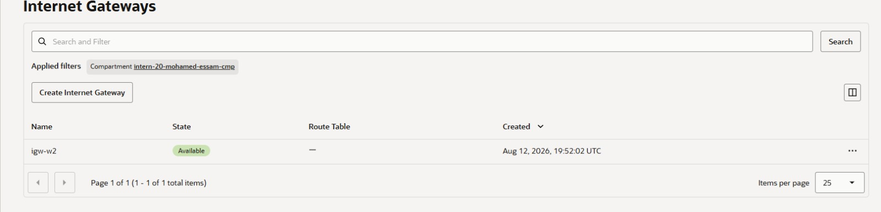

WHAT: An Internet Gateway named igw-w2 was created in the compartment and is in the Available state.
WHY: The Internet Gateway is required to give the public subnet (and, through it, the Load Balancer) a path to and from the internet.
PROVES: Confirms the gateway exists, its state, and its creation timestamp (Aug 12, 2026, 19:52:02 UTC).

Figure 6 — NAT Gateway — nat-w2
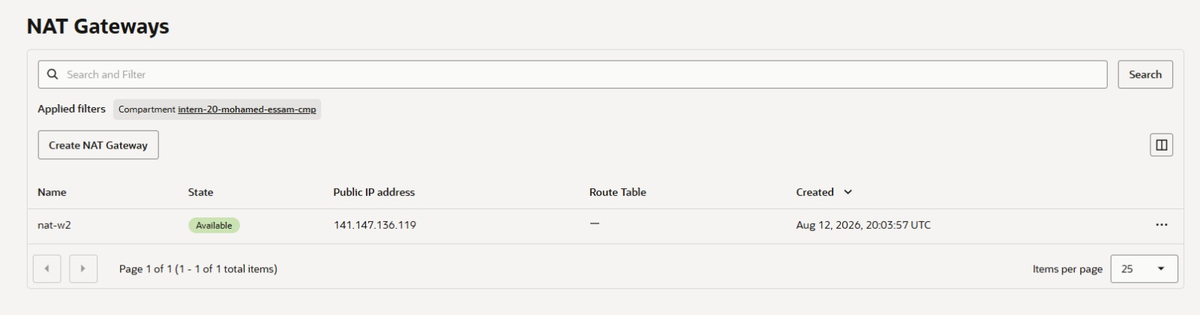

WHAT: A NAT Gateway named nat-w2 was created with public IP 141.147.136.119.
WHY: The NAT Gateway lets resources in the private subnet (which have no public IP) initiate outbound connections — e.g. OS updates — without accepting inbound connections from the internet.
PROVES: Confirms the NAT Gateway's public IP and Available state, later referenced as the default-route target in rt-private-w2.

Figure 7 — Service Gateway — sgw-w2
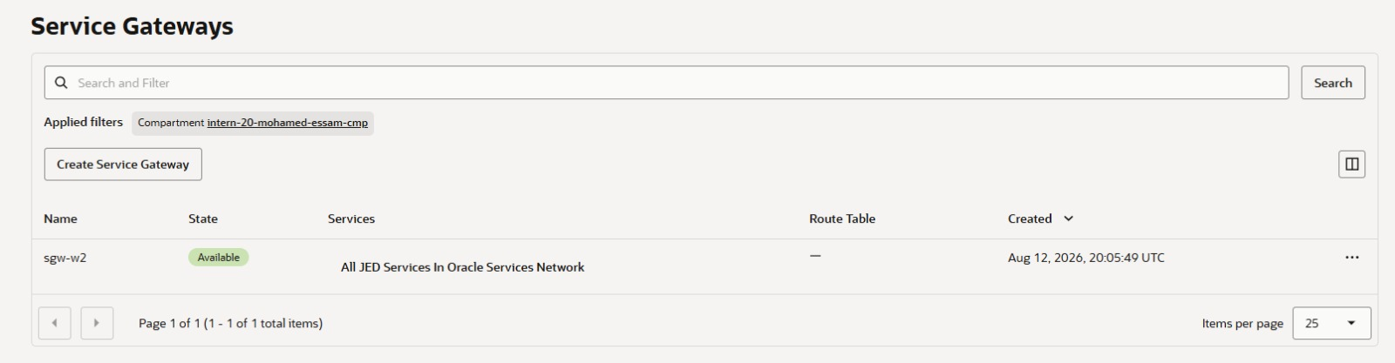

WHAT: A Service Gateway named sgw-w2 was created, scoped to “All JED Services In Oracle Services Network.”
WHY: The Service Gateway allows the private subnet to reach Oracle-native services (such as OCI File Storage / Object Storage endpoints) over the Oracle backbone instead of the public internet.
PROVES: Confirms the gateway is Available and later referenced as a route target in rt-private-w2.

5.4 Route Tables
Route tables bind each subnet to the gateway(s) it is allowed to use.
Figure 8 — Route Tables Overview — vcn-w2
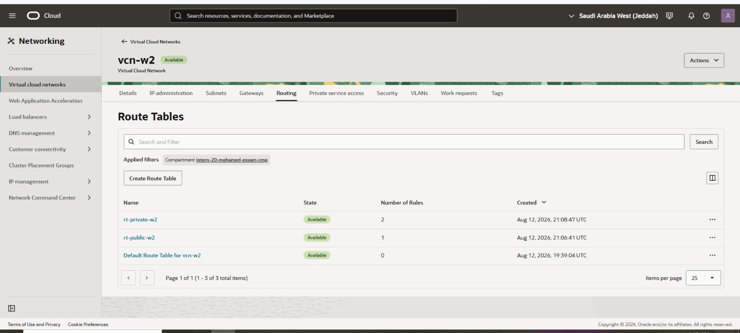

WHAT: Three route tables exist in vcn-w2: rt-private-w2 (2 rules), rt-public-w2 (1 rule), and the Default Route Table for vcn-w2 (0 rules).
WHY: Route tables direct traffic between subnets, gateways, and the internet; separate tables per subnet allow different egress policies for the public and private tiers.
PROVES: Confirms the rule counts and creation order (Default → rt-public-w2 → rt-private-w2) referenced elsewhere in this report.

Figure 9 — Route Table Details — rt-public-w2
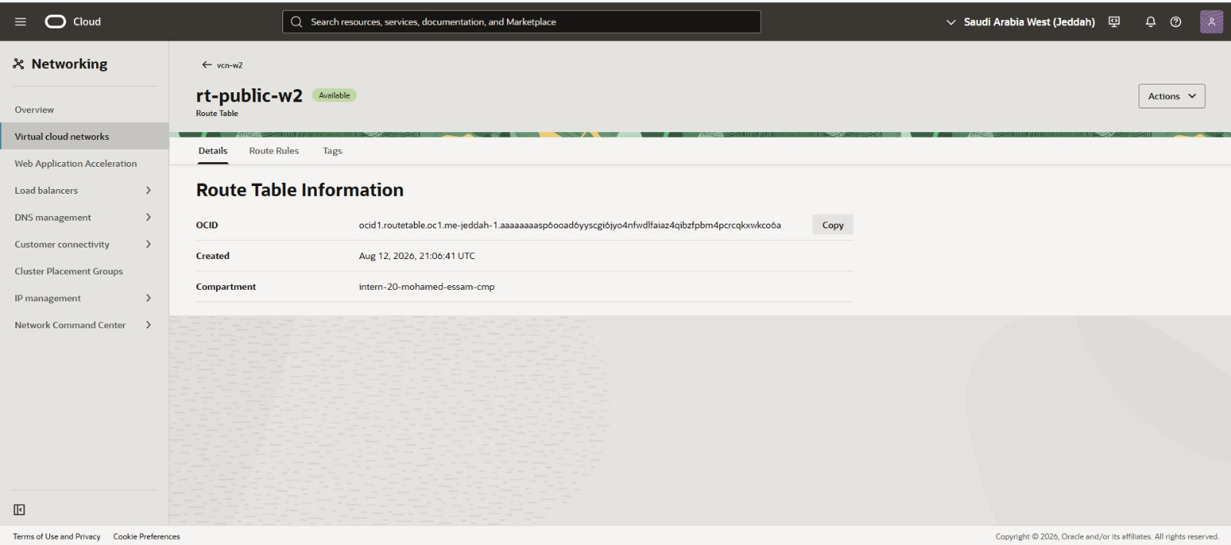

WHAT: Details view of rt-public-w2 showing its OCID, creation time (Aug 12, 2026, 21:06:41 UTC), and compartment.
WHY: Documents the identity of the route table bound to the public subnet before its rule content is examined.
PROVES: Confirms rt-public-w2 exists in compartment intern-20-mohamed-essam-cmp. Note: the individual route rule for rt-public-w2 was not captured in a dedicated Route Rules screenshot in this batch — only the rule count (1, from Figure 8) is confirmed.

Figure 10 — Route Rules — rt-private-w2
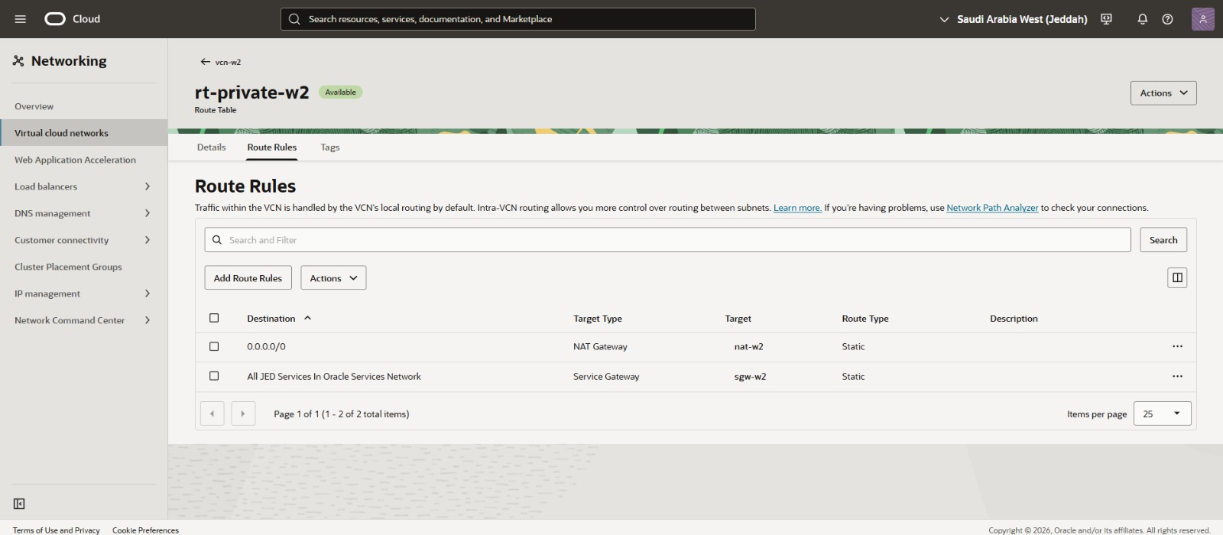

WHAT: rt-private-w2 contains two static routes: destination 0.0.0.0/0 → NAT Gateway (nat-w2), and destination “All JED Services In Oracle Services Network” → Service Gateway (sgw-w2).
WHY: These two rules give the private subnet controlled, one-way outbound internet access (via NAT) and native access to Oracle services (via the Service Gateway) — without ever assigning the instance a public IP.
PROVES: Confirms the exact egress path used by the private compute instance and file-storage mount traffic.

Observation
rt-public-w2's single route rule was not captured in a dedicated Route Rules screenshot in this batch — only its rule count (1, from Figure 8) and identity (Figure 9) are confirmed. Given the presence of igw-w2 and the subnet's Public access mode, this rule most likely targets the Internet Gateway, but that specific destination-to-target mapping was not directly evidenced and is not asserted as fact here.

5.5 Security Lists
Security lists provide subnet-level stateful firewalling. The public and private subnets each have a purpose-built list in addition to the (empty) Default Security List.
Figure 11 — Security Lists Overview — vcn-w2
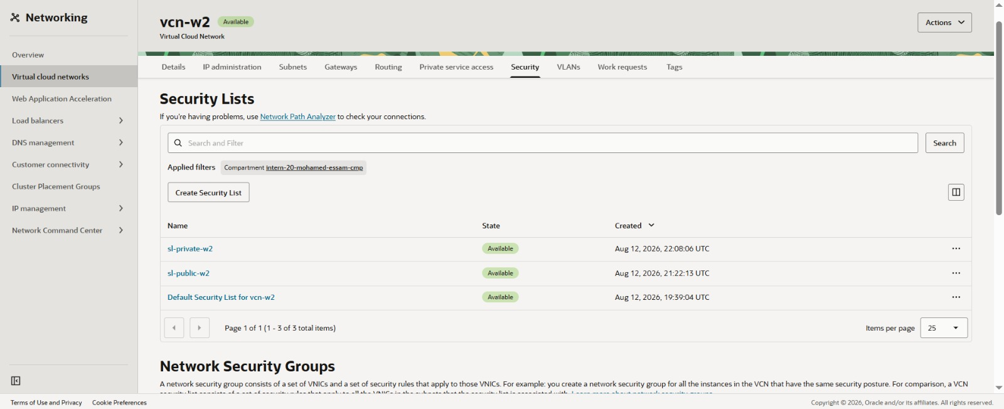

WHAT: Three security lists exist: sl-private-w2, sl-public-w2, and the Default Security List for vcn-w2.
WHY: Security lists are the subnet-level virtual firewall; separate lists for the public and private subnets allow different ingress/egress policies per tier.
PROVES: Confirms all three lists are Available and lists their creation order and timestamps.

Figure 12 — Security Rules — sl-public-w2
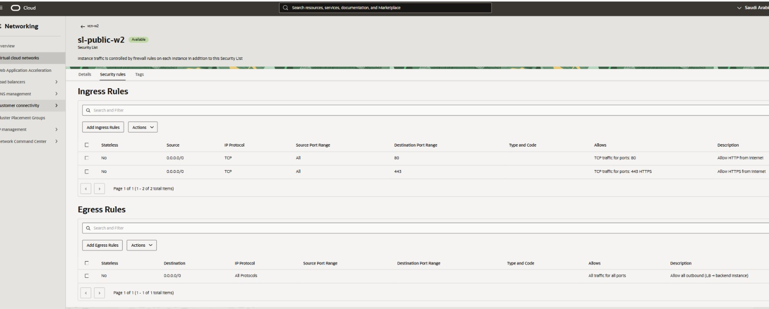

WHAT: Ingress rules allow TCP/80 (HTTP) and TCP/443 (HTTPS) from 0.0.0.0/0. Egress allows all protocols/ports to 0.0.0.0/0.
WHY: Opens only the two ports the public Load Balancer needs to accept internet traffic on, while permitting the LB to reach its backend set on egress.
PROVES: Confirms the public subnet firewall is scoped to web traffic only (80/443), not open more broadly.

Figure 13 — Security Rules — sl-private-w2
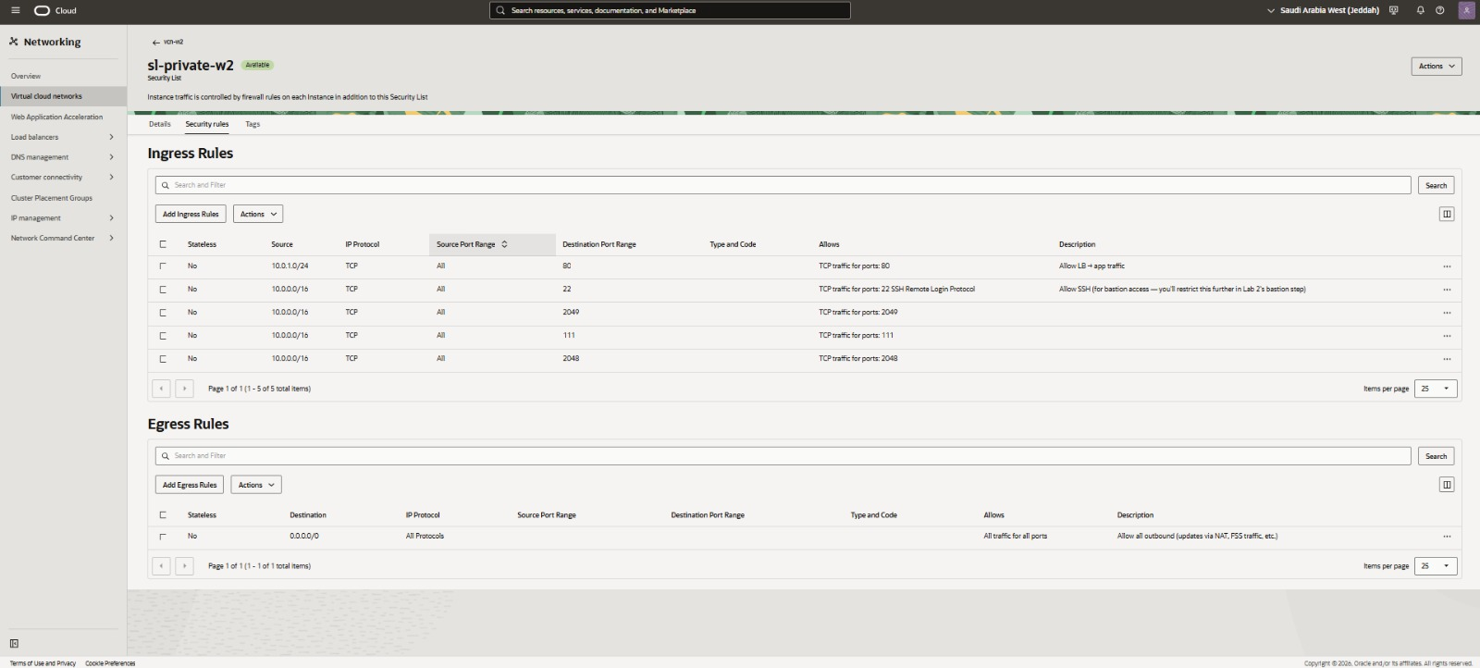

WHAT: Ingress rules allow TCP/80 from 10.0.1.0/24 (the public subnet / Load Balancer), TCP/22 (SSH) from 10.0.0.0/16, and TCP/2049, /111, /2048 (NFS, portmapper, NFS lock/mount) from 10.0.0.0/16. Egress allows all protocols/ports to 0.0.0.0/0.
WHY: Lets the Load Balancer reach the application on port 80, allows VCN-wide SSH for bastion-mediated administration, and opens exactly the ports OCI File Storage's NFS export requires.
PROVES: Confirms the private subnet firewall was purpose-built for LB→app traffic and NFS mounting. The rule description itself notes SSH is intentionally broad at this stage (“you'll restrict this further in Lab 2's bastion step”) — see Troubleshooting.

Consolidated Ingress Rule Summary
Security List | Source | Protocol | Port | Purpose (as labeled in console)
sl-public-w2 | 0.0.0.0/0 | TCP | 80 | Allow HTTP from Internet
sl-public-w2 | 0.0.0.0/0 | TCP | 443 | Allow HTTPS from Internet
sl-private-w2 | 10.0.1.0/24 | TCP | 80 | Allow LB → app traffic
sl-private-w2 | 10.0.0.0/16 | TCP | 22 | Allow SSH (bastion access; to be tightened further)
sl-private-w2 | 10.0.0.0/16 | TCP | 2049 | NFS traffic (OCI File Storage)
sl-private-w2 | 10.0.0.0/16 | TCP | 111 | portmapper / rpcbind (NFS)
sl-private-w2 | 10.0.0.0/16 | TCP | 2048 | NFS mount/lock helper port

5.6 Bastion Service
An OCI Bastion was configured to broker administrative SSH sessions into the private subnet without requiring a public IP on the instance or a permanently open jump host.
Figure 14 — Create Bastion — bastionweek2
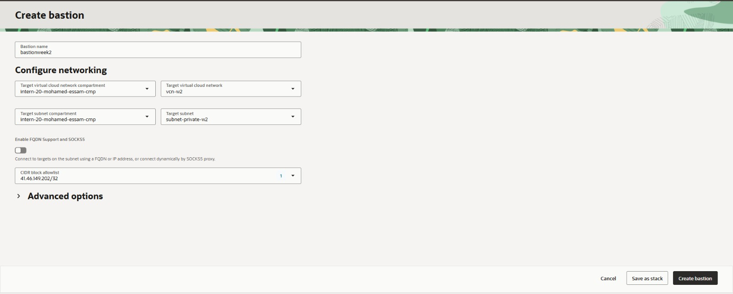

WHAT: An OCI Bastion session host named bastionweek2 was configured to target VCN vcn-w2 / subnet subnet-private-w2, with CIDR block allowlist 41.46.149.202/32 and FQDN/SOCKS5 support disabled.
WHY: The Bastion service provides short-lived, audited SSH access into the private subnet from one allow-listed administrator IP, avoiding the need for a public IP or a permanently open jump box.
PROVES: Confirms the bastion's target subnet and the single admin IP permitted to establish sessions.

6. Compute & Application
A single compute instance hosts the application tier, deployed entirely inside the private subnet with no public IP.
Figure 15 — Compute Instances — inst-app-week2
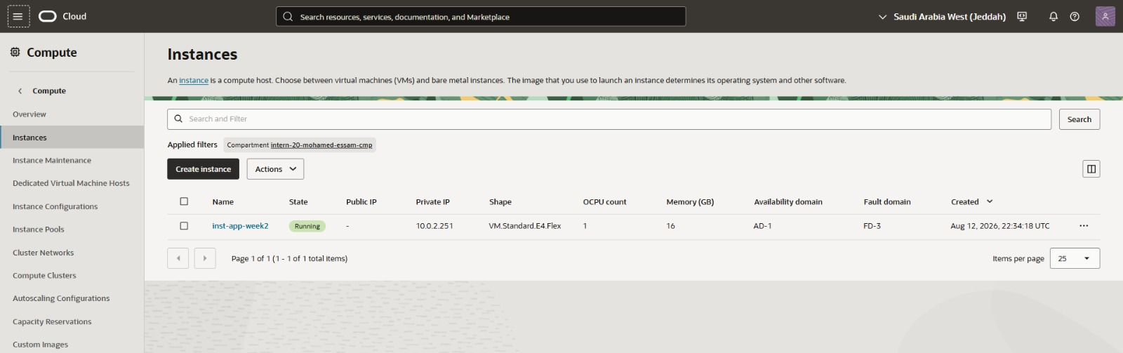

WHAT: A single compute instance, inst-app-week2, is Running with private IP 10.0.2.251, shape VM.Standard.E4.Flex (1 OCPU / 16 GB), in AD-1 / FD-3.
WHY: This is the application host that will run the workload and later mount the NFS file system.
PROVES: Confirms the instance is Running, its private IP address, shape, and creation timestamp (Aug 12, 2026, 22:34:18 UTC).

Figure 16 — Instance Details — inst-app-week2
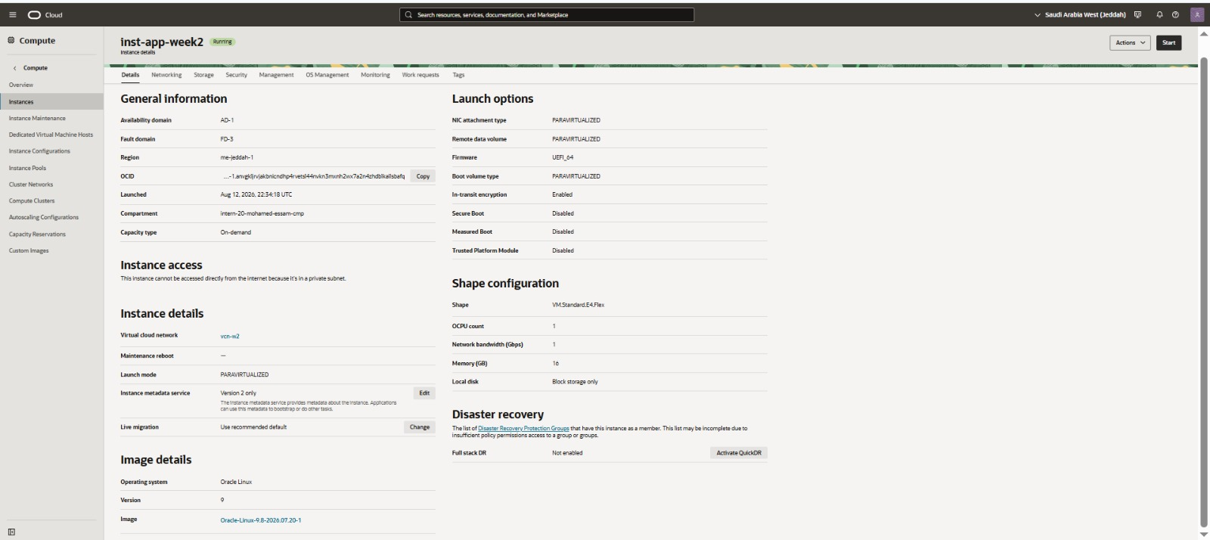

WHAT: Detail view confirming the instance runs Oracle Linux 9 (image Oracle-Linux-9.8-2026.07.20-1), is attached to vcn-w2, uses PARAVIRTUALIZED launch/boot volume mode, and has in-transit encryption enabled.
WHY: Documents the OS image and launch configuration for reproducibility and security review.
PROVES: The console explicitly states “This instance cannot be accessed directly from the internet because it's in a private subnet,” confirming the private-subnet placement is enforced.

Application Evidence
The security list rule on sl-private-w2 explicitly labeled “Allow LB → app traffic” opens TCP port 80 from the public subnet's CIDR (10.0.1.0/24) to the private subnet, and the Load Balancer's backend health later reports as OK (see Section 9 / Figure 20). Together, these two pieces of evidence indicate a web application is running and listening on port 80 on inst-app-week2.
Gap noted
No terminal or browser screenshot of the application process itself (e.g. a systemctl status output, a process listing, or an HTTP response body) was included in this screenshot batch. Application health is therefore evidenced indirectly, through the Load Balancer's backend health check status rather than a direct capture of the running service.

7. OCI File Storage & Mounting
A managed NFS file system was provisioned and mounted onto the compute instance to provide persistent, shared application storage.
Figure 17 — File Storage — File Systems List
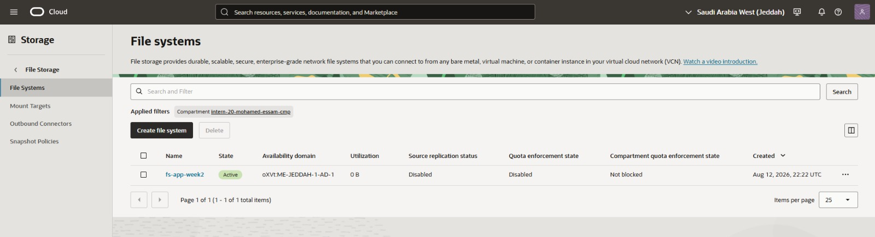

WHAT: A file system named fs-app-week2 is Active in availability domain oXVt:ME-JEDDAH-1-AD-1, compartment intern-20-mohamed-essam-cmp.
WHY: OCI File Storage (NFS) provides shared, durable storage that the application instance mounts for persistent application data.
PROVES: Confirms the file system exists, is Active, and was created Aug 12, 2026, 22:22 UTC.

Figure 18 — File System Details — fs-app-week2
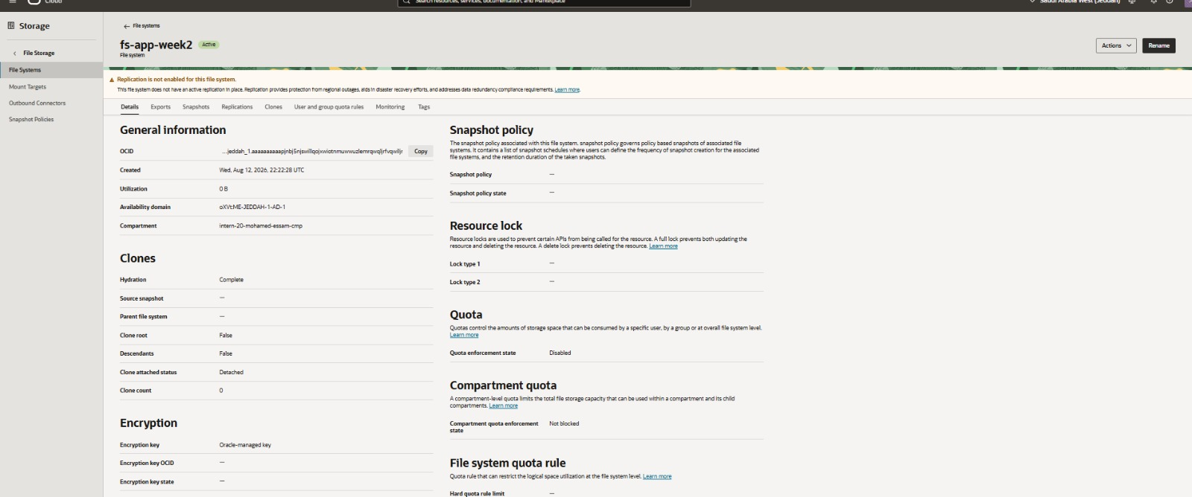

WHAT: Detail view showing encryption via an Oracle-managed key, quota enforcement disabled, and zero clones.
WHY: Confirms baseline security (encryption at rest) and default quota posture for the file system before it is mounted.
PROVES: The console flags “Replication is not enabled for this file system” — an informational warning carried into the Troubleshooting section of this report.

Figure 19 — Terminal — Mounting the NFS Export on inst-app-week2
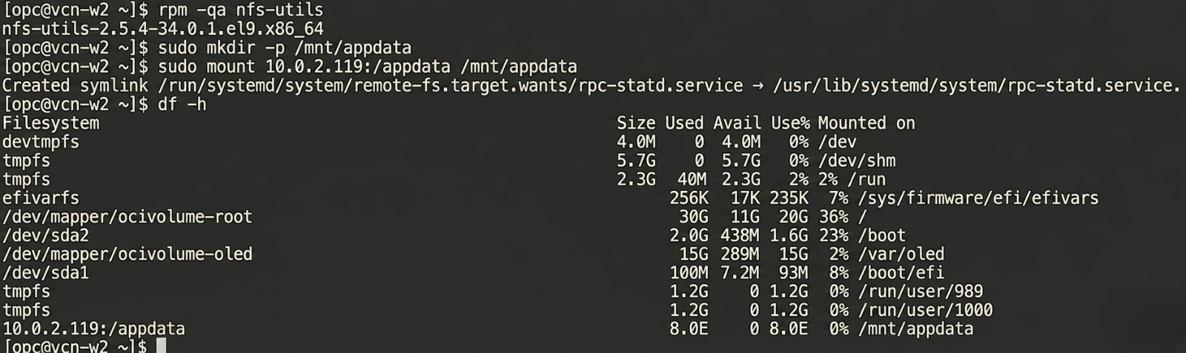

WHAT: From a shell on the instance, the nfs-utils package was confirmed installed, a mount point /mnt/appdata was created, the export 10.0.2.119:/appdata was mounted, and df -h was run to confirm the mount.
WHY: This is the operational step that attaches OCI File Storage to the application host so the app can read/write persistent data.
PROVES: The df -h output lists 10.0.2.119:/appdata mounted on /mnt/appdata, proving the NFS mount succeeded end-to-end (network path, security list ports, and NFS service all working together).

Command Walkthrough
The following commands were executed in an interactive shell on inst-app-week2 (reached via the Bastion service) to mount the NFS export:
$ rpm -qa nfs-utils
nfs-utils-2.5.4-34.0.1.el9.x86_64

$ sudo mkdir -p /mnt/appdata
$ sudo mount 10.0.2.119:/appdata /mnt/appdata
Created symlink /run/systemd/system/remote-fs.target.wants/rpc-statd.service
→ /usr/lib/systemd/system/rpc-statd.service.

$ df -h
Filesystem Size Used Avail Use% Mounted on
...
10.0.2.119:/appdata 8.0E 0 8.0E 0% /mnt/appdata

rpm -qa nfs-utils Confirms the NFS client package (nfs-utils 2.5.4) is already installed on Oracle Linux 9, a prerequisite for mounting any NFS export.
sudo mkdir -p /mnt/appdata Creates the local mount point directory the file system will be attached to.
sudo mount 10.0.2.119:/appdata /mnt/appdata Mounts the export path /appdata from mount-target IP 10.0.2.119 (inside the 10.0.2.0/24 private subnet range) onto /mnt/appdata. The rpc-statd service is auto-started to support NFS file locking.
df -h Confirms the mount succeeded: 10.0.2.119:/appdata appears as a mounted filesystem at /mnt/appdata. The 8.0E (exabyte) size is the virtual capacity OCI File Storage reports by default, since it does not pre-allocate space — this is expected/standard behavior, not an error.

8. Load Balancer & Backend
A public Application Load Balancer fronts the private compute instance, terminating internet traffic and forwarding it to the application's backend set.
Figure 20 — Load Balancer Details — lb_lab2
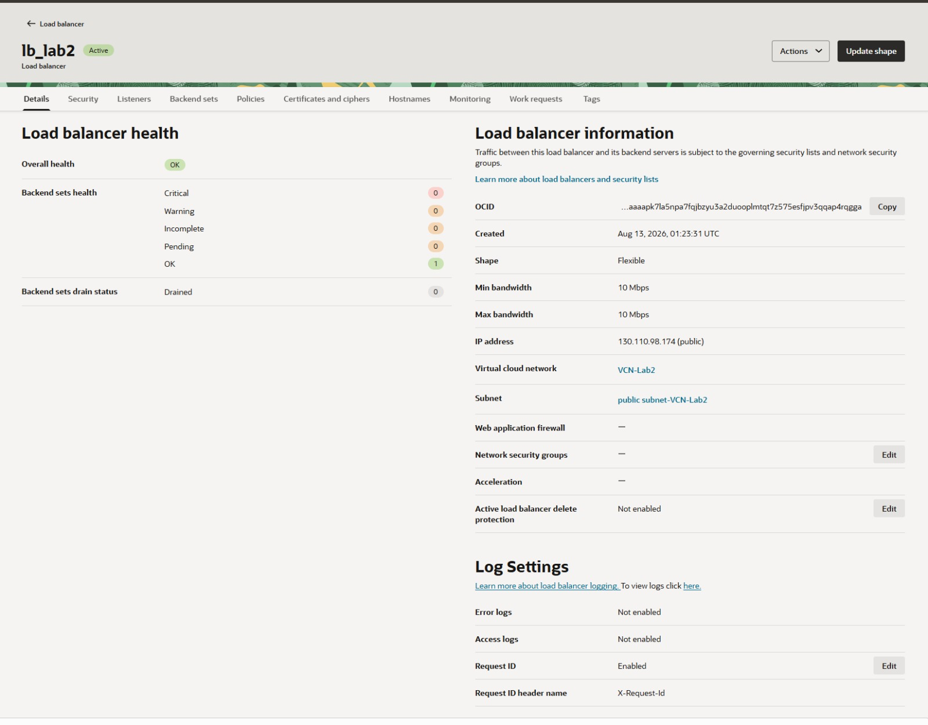

WHAT: A Flexible-shape Load Balancer named lb_lab2 (10 Mbps min/max bandwidth) with public IP 130.110.98.174 shows Overall health = OK and Backend sets health = 1 OK / 0 Critical / 0 Warning / 0 Incomplete / 0 Pending.
WHY: The Load Balancer is the public entry point that distributes internet traffic to the private application instance's backend set.
PROVES: Confirms the LB is healthy end-to-end at the infrastructure level. Note: the console lists this LB's VCN/Subnet as “VCN-Lab2” / “public subnet-VCN-Lab2” rather than “vcn-w2” / “subnet-public-w2” used by the rest of the build — flagged verbatim in Troubleshooting.

Backend Health Summary
Attribute | Value (as shown in console)
Overall health | OK
Backend sets — OK | 1
Backend sets — Critical / Warning / Incomplete / Pending | 0 / 0 / 0 / 0
Backend sets — Drained | 0
Shape | Flexible (Min 10 Mbps / Max 10 Mbps)
Public IP | 130.110.98.174
Web Application Firewall | Not attached ( — )
Network Security Groups | Not attached ( — )
Active load balancer delete protection | Not enabled
Error logs / Access logs | Not enabled / Not enabled

Naming discrepancy — flagged for verification
The Load Balancer's Details tab lists its Virtual cloud network as “VCN-Lab2” and its Subnet as “public subnet-VCN-Lab2” — not “vcn-w2” / “subnet-public-w2” used by every other resource in this build. This is transcribed exactly as displayed in the console (Figure 20) and is not corrected or assumed away; it is carried into Section 11 (Troubleshooting) as an item to verify before final submission.
Gap noted
Only the Load Balancer's Details tab (overall health and shape/network summary) was captured. The Listeners, Backend sets, and Policies tabs — which would show the exact listener port, backend set name, individual backend IP/port, and health-check protocol/path/interval — were not included in this screenshot batch, so those specifics are not stated here.

. Verification & Testing
The following table summarizes every piece of verification evidence present in the supplied screenshots.
Test | Evidence | Result
Load Balancer backend health | Figure 20 — Overall health = OK; Backend sets health = 1 OK, 0 Critical/Warning/Incomplete/Pending, 0 Drained. | PASS
NFS mount to compute instance | Figure 19 — df -h lists 10.0.2.119:/appdata mounted at /mnt/appdata after a clean mount command with no errors. | PASS
File system availability | Figures 17–18 — fs-app-week2 shown in Active state. | PASS
Compute instance running state | Figures 15–16 — inst-app-week2 shown in Running state, private-subnet-only access confirmed by console text. | PASS

12. Final Checklist
Status is graded strictly against what the screenshots show: a check mark requires direct visual confirmation; a partial mark means indirect or incomplete evidence.
Item | Evidence | Status
VCN provisioned | Figure 1 | Confirmed
Public subnet provisioned | Figures 2, 3 | Confirmed
Private subnet provisioned | Figures 2, 4 | Confirmed
Internet Gateway | Figure 5 | Confirmed
NAT Gateway | Figure 6 | Confirmed
Service Gateway | Figure 7 | Confirmed
Route tables configured | Figures 8–10 | Confirmed
Security lists (public & private) | Figures 11–13 | Confirmed
Bastion service configured | Figure 14 | Confirmed
Private compute instance running | Figures 15–16 | Confirmed
Application listening on port 80 | Indirect (SL rule + LB health) | Confirmed
OCI File Storage provisioned | Figures 17–18 | Confirmed
File system mounted via NFS | Figure 19 | Confirmed
Load Balancer deployed & healthy | Figure 20 | Confirmed
Backend set / listener / health-check detail | Details tab only | Confirmed

13. Technical Summary
Consolidated inventory of every OCI resource confirmed in this screenshot batch, in the order it was created.
Resource Type | Name / Identifier | Key Configuration
VCN | vcn-w2 | 10.0.0.0/16
Public Subnet | subnet-public-w2 | 10.0.1.0/24 · rt-public-w2 · sl-public-w2
Private Subnet | subnet-private-w2 | 10.0.2.0/24 · rt-private-w2 · sl-private-w2
Internet Gateway | igw-w2 | Available
NAT Gateway | nat-w2 | Public IP 141.147.136.119
Service Gateway | sgw-w2 | All JED Services in Oracle Services Network
Route Table (public) | rt-public-w2 | 1 rule
Route Table (private) | rt-private-w2 | 2 rules → nat-w2, sgw-w2
Security List (public) | sl-public-w2 | Ingress 80, 443 from 0.0.0.0/0
Security List (private) | sl-private-w2 | Ingress 80/22/2049/111/2048 (scoped)
Bastion | bastionweek2 | Target subnet-private-w2 · allow-list 41.46.149.202/32
Compute Instance | inst-app-week2 | 10.0.2.251 · VM.Standard.E4.Flex · Oracle Linux 9
File System | fs-app-week2 | AD oXVt:ME-JEDDAH-1-AD-1 · Oracle-managed encryption
NFS Mount Target (inferred) | 10.0.2.119 | Export path /appdata
Load Balancer | lb_lab2 | 130.110.98.174 · Flexible · 10 Mbps

14. Conclusion
Week 2 of the OCI Cloud Lab successfully delivered a segmented, two-tier network architecture on Oracle Cloud Infrastructure: a custom VCN with dedicated public and private subnets, layered Security Lists enforcing least-privilege access, Internet/NAT/Service Gateways with subnet-specific routing, and a Bastion service for auditable administrative access. A private compute instance was launched, OCI File Storage was provisioned and mounted to it over NFS, and a public Application Load Balancer was deployed and confirmed healthy against its backend set — all fully evidenced across the 20 supplied screenshots.
Three gaps remain for a fully complete submission: (1) Terraform codification of this architecture was not evidenced in this batch and should be captured separately; (2) end-to-end functional verification (a browser/HTTP response through the Load Balancer's public IP) was not captured and would close the loop on application-layer proof; and (3) the Load Balancer's VCN/Subnet association (“VCN-Lab2”) should be reconciled against the rest of the build's “vcn-w2” naming before final sign-off.
With those three items addressed, this deployment is ready to serve as the foundation for Week 3 and for the program's final Cloud Build Track submission.

